TRAFFIC JAM
Dhaka is a city of jam. No one can move without facing this except the glorious politicians, who can do everything for their own profit, but nothing for the mother land. As a result, the politicians are not interested to overcome it. Moreover they create a jam of approximately infinite length wherever they go.

Now, some patriotic people (non politician) are interested to eradicate this problem. They want to build roads (in public private partnership) around the city. So, they think Dhaka as a rectangular shape & want to build roads over the sides of the rectangle. They also want to make a road diagonally in which they are interested to keep an escape rout perpendicularly to the diagonal to go to an opposite vertex. The following figure shows it.

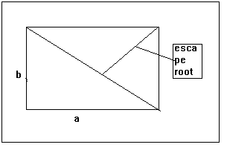
You are hired as a senior programmer to calculate the length of the escape route when the length & width of the rectangular Dhaka is known. It is guaranteed that, no politician will be allowed in this road.

Input:
The input contains several test cases. The first line contains T, number of test cases. Then T cases followed. Each case contains two integers, a & b, length & width respectively.

Output:
Output the length of the escape root rounded to 2 decimal points in a single line.

Sample input:
2
4 3
10 5

Sample output:
2.40
4.47

